PUBLISH DATA TO THE IBM CLOUD

|  |  |
| --- | --- |
| Team ID | PNT2022TMID15690 |
| Project Name | Project – IOT Based Real time River  Water Quality Monitoring and Control System |

You can publish your virtual data to catalogs in Watson Knowledge Catalog. An administrator can configure Data Virtualization to automatically publish all virtual objects that are created in the user interface to a configured primary catalog.

By publishing your virtual data to a catalog, you can:

*Organize, label, classify, and search for the published data assets with global search.

*Govern the virtual data asset and subject it to data protection rules by [enabling policy enforcement i](https://www.ibm.com/docs/en/SSQNUZ_4.5.x/svc-dv/enable-strict.html)n Data

*Navigate to **Service settings**.

*On the **Governance** tab, enable the **Enforce publishing to a governed catalog** option.

A list of governed catalogs that you have Admin access to is shown. You must select a governed catalog as your primary catalog. When you set a primary catalog, all

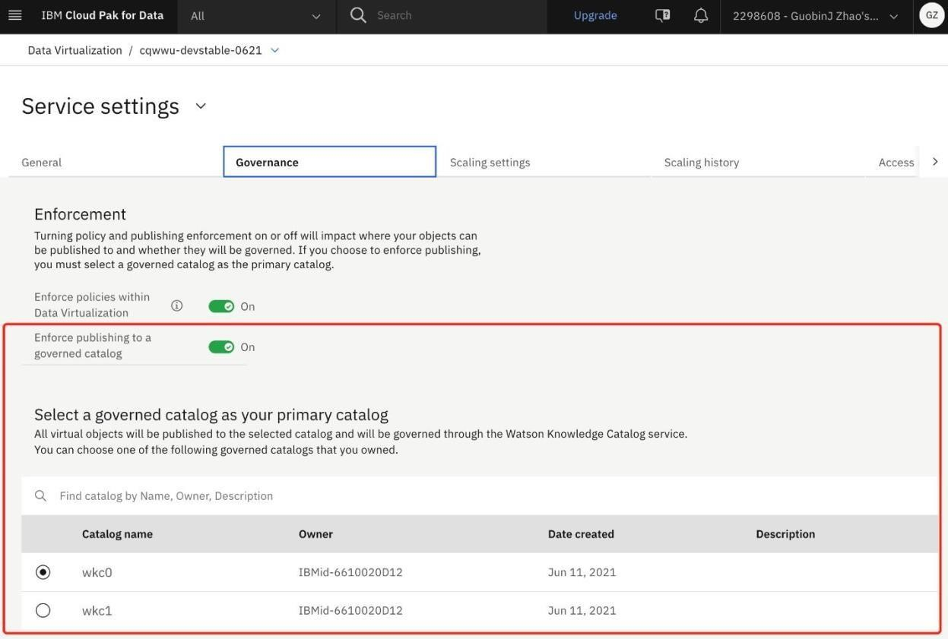

virtualized objects are published to this catalog automatically. The **Publish to catalog** option is disabled when you review your cart and virtualize tables.

1. On the service menu, click **Virtualization** > **Virtualized data**.
2. Select the virtual objects that you want to publish and click **Publish to catalog**.

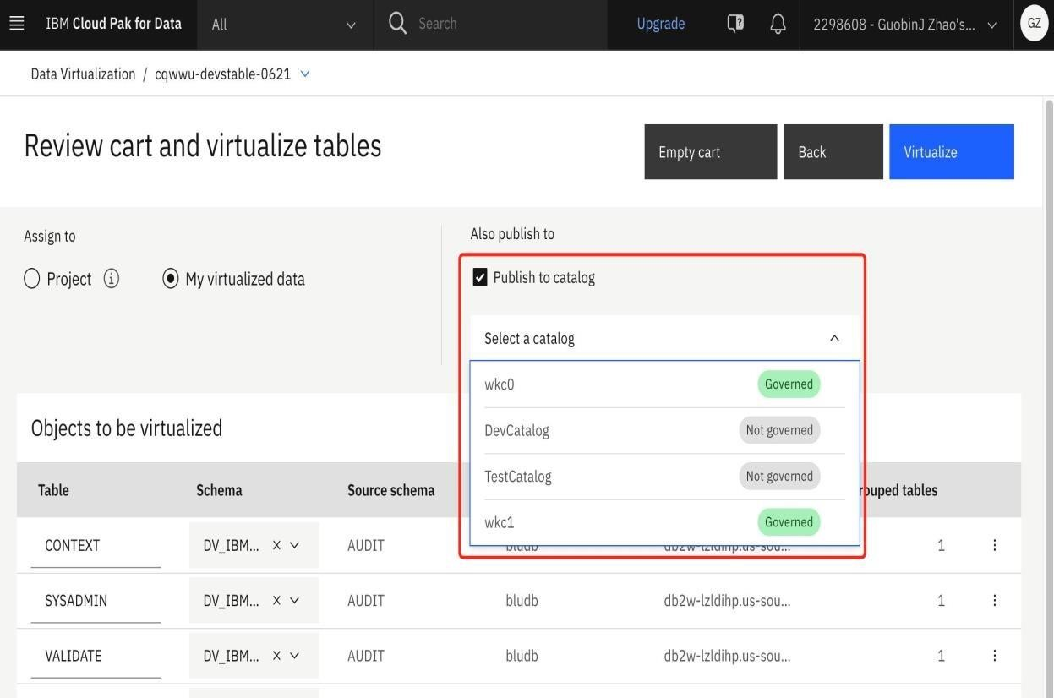

1. Continue with the virtualization process